9. Creating views to provide a customized view of the database.
Create Table:
CREATE TABLE employees2 (
emp_id INT PRIMARY KEY AUTO_INCREMENT,
emp_name VARCHAR(50),
department VARCHAR(30),
salary DECIMAL(10,2));
Insert some sample data:
INSERT INTO employees2 (emp_name, department, salary) VALUES
('Saniya', 'IT', 40000),
('Khushi', 'IT', 55000),
('Punam', 'HR', 42000),
('Nikita', 'Finance', 40000),
('Snehal', 'Finance', 35000),
('Sanika', 'HR', 28000);
select*from employees2;
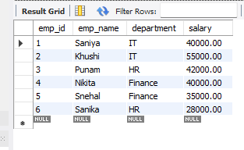
- Simple View:
CREATE VIEW employees2_salary_view AS
SELECT emp_name, salary
FROM employees2;
SELECT*FROM employees2_salary_view;
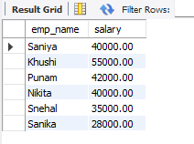
- Filtered View:
CREATE VIEW it_employees2 AS
SELECT emp_id,emp_name,salary
FROM employees2
WHERE department='IT';
SELECT*FROM it_employees2;
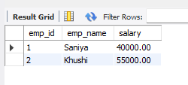
- Aggregated View :
CREATE VIEW department_salary_summary AS
SELECT department,
COUNT(*) AS total_employees,
SUM(salary) AS total_salary,
AVG(salary) AS avg_salary,
MAX(salary) AS highest_salary,
MIN(salary) AS lowest_salary
FROM employees2
GROUP BY department;
SELECT*FROM department_salary_summary;

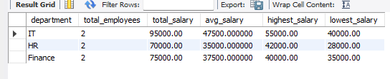
4. Updating a View :
CREATE OR REPLACE VIEW employees2_salary_view AS
SELECT emp_name,department,salary
FROM employees2;
SELECT*FROM employees2_salary_view;
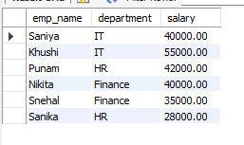
5 . Dropping a View :
DROP VIEW IF EXISTS it_employees2;

